Project Design Phase-II
Data Flow Diagram & User Stories
Date | 23 June 2026
Name | Dinesh Dhasara
Project Name | CampusMind AI – Smart Campus Incident Management System
Maximum Marks | 4 Marks

Data Flow Diagrams
A Data Flow Diagram (DFD) is a graphical representation of how information flows through the CampusMind AI application. It illustrates how student complaints are submitted through the Service Portal, processed using ServiceNow Business Rules and Flow Designer, assigned to the appropriate department, monitored using Service Level Agreements (SLA), updated by administrators, and finally resolved with notifications sent back to students. The DFD also demonstrates how reports and dashboards retrieve data from the Campus Incident database to provide real-time analytics and performance monitoring.
CampusMind AI – Smart Campus Incident Management System – Data Flow Diagram
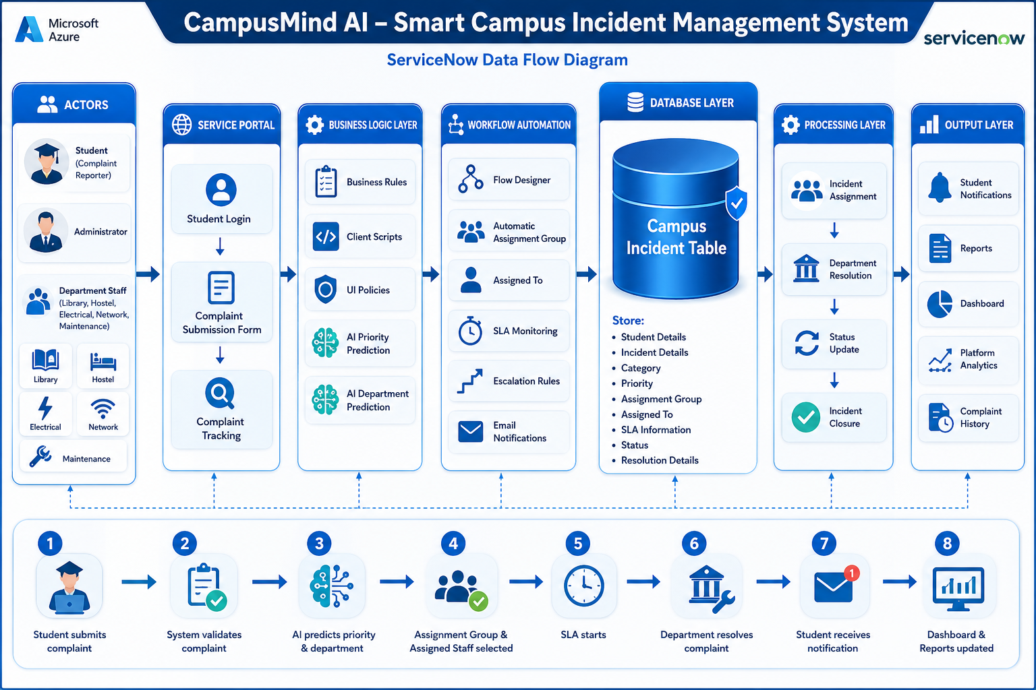

User Stories
User Type | Module | User Story ID | User Story / Task | Input | System Process | Expected Output
Student | Complaint Submission | US-1 | As a student, I can submit a campus complaint through the Service Portal. | Student Details, Category, Complaint Description, Location | System validates the input and creates a new Campus Incident record. | Complaint is submitted with a unique Incident Number.
Student | Complaint Tracking | US-2 | As a student, I can view the current status of my submitted complaint. | Incident Number | System retrieves the latest complaint status. | Student can monitor complaint progress in real time.
Administrator | Incident Assignment | US-3 | As an administrator, I can assign complaints to the appropriate department and staff member. | Assignment Group, Assigned To | System updates assignment details and routes the complaint. | Complaint is assigned to the correct department.
Administrator | Incident Resolution | US-4 | As an administrator, I can update complaint status and resolution details. | Status, Resolution Notes | System records resolution information and updates the incident. | Complaint status changes to Resolved or Closed.
Administrator | SLA & Escalation | US-5 | As an administrator, I can monitor SLA timelines and receive escalation alerts for overdue complaints. | SLA Policies, Incident Status | System tracks SLA timers and automatically triggers escalation if required. | SLA compliance is maintained and overdue incidents are escalated.
Student | Notifications | US-6 | As a student, I receive notifications whenever my complaint status changes. | Incident Updates | System sends email notifications automatically. | Student receives real-time status updates.
Administrator | Reports & Dashboard | US-7 | As an administrator, I can view reports and dashboards showing complaint statistics and departmental performance. | Incident Data | System generates analytical reports and dashboard visualizations. | Interactive reports and dashboards are displayed.

